Diagnostics Stack Assignment

(2 Questions)

# Question 1:

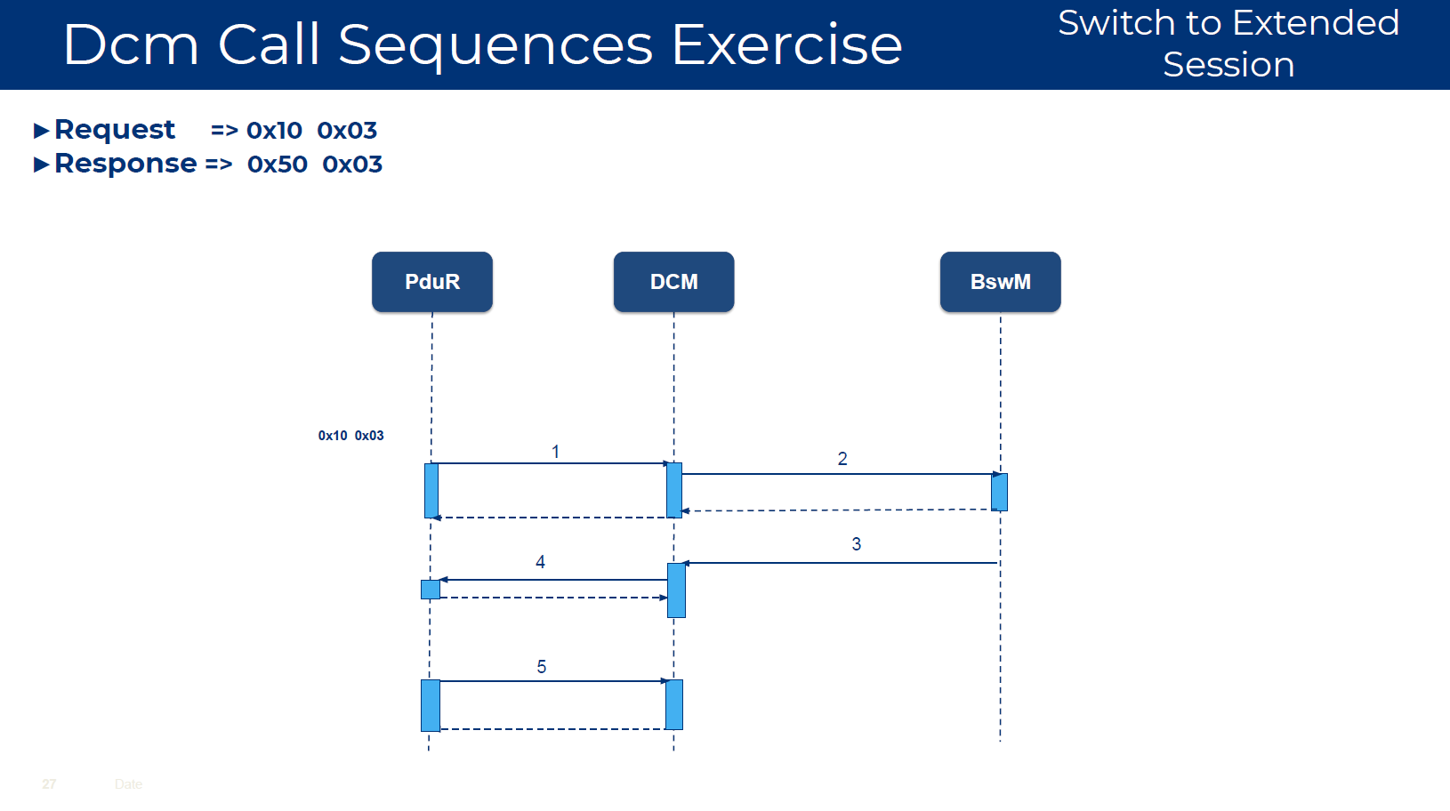

1. Dcm_TpRxIndication()
2. BswM_Dcm_RequestSessionMode(Dcm_SesCtrlType)
3. BswM_Dcm_RequestSessionMode()
4. PduR_DcmTransmit
5. Dcm_TxConfirmation

# Question 2:

Please “enable editing the document” then click on the excel icon below

